|  |
| --- |
| logo.jpg  **Pattern Recognition Course**  **Computer Science Department**  **Faculty of Computer and Information Sciences**  **Ain Shams University, Egypt** |
| **A Report of Final Project**  **By** |

|  |  |
| --- | --- |
| **Team no.: [Team 2 .]**  **[Mohamed Mawed] - [Section 4.]**  **[Mohamed Samiir] - [Section 4.]**  **[Mohamed Kotb]- [Section 4.]**  **[Mohamed Mohsen] - [Section 4.]**  **[Ibrahim Maghed] - [Section 1.]** | |
| **Project Title** | |
| **"*Object Detection and Recognition*"** | |

**1st Semester 2017\2018**

# **Comparative Study**

1) The overall accuracy

Table 1. Overall Accuracy (%)

|  |  |  |  |
| --- | --- | --- | --- |
|  | **Modified KNN** | **r-Near Neighbors** | **SVM** |
| **GLCM** | 54% when K = 6 | 27% when R = 2 |  |
| **Run-Length Matrix** | 43% when K = 9 | 39% when R = 110 |  |
| **GLCM + Run-Length Matrix** | 58% when K= 8 | 39% when R = 110 |  |
| **SIFT (Bonus)** |  |  |  |

2) Screenshot of the confusion matrix.

AllFeatures (MKNN) AllFeatures (RNN)

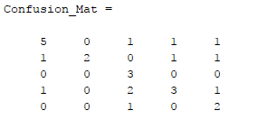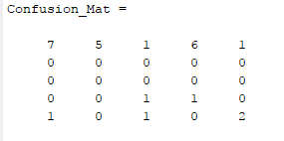

GLCM(MKNN) GLCM(RNN)

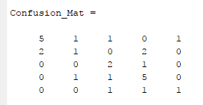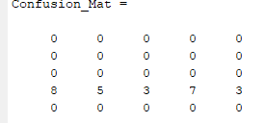

RunLength (MKNN) RunLength(RNN)

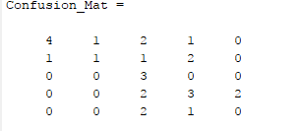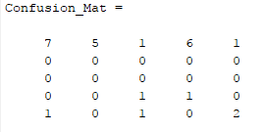

# **Conclusion**

This section should contain your conclusion about your work. Mention what is the best classification algorithm based on the values of table 1 with your interpretation.